KHWOPA ENGINEERING COLLEGE
EIGHTH sEMESTER ASSESSMENT - 2016
lEVEL:- B. E. Computer/VIII
SUBJECT:- BEG475VB, Elective–II (VB.Net C# System)
FULL MARKS:- 80
TIME:- 03:00 hrs. 2073/05/16 PASS MARKS:- 32

Candidates are required to give their answers in their own words as far as practicable.
The figures in the margin indicated full marks.

Answer any EIGHT questions.
Q.1.a) Explain advantages and disadvantages of C# and VB.net programming. [5]
b) Explain .NET Architecture for Language and Platform Independence with labeled diagram. [5]

Q.2.a) Explain boxing and Unboxing with suitable program. [5]

b) Describe the working mechanism of ASP.NET. [5]

Q.3.a) Why Exception Handling is required in programming? Explain with Example. [2+3]
b) Explain procedure and function with example. [5]

Q.4.a) Differentiate between iteration and recursion, as a programmer which one you recommend. Justify. [3+2]

b) Mention the reasons of using Inheritance in object oriented programming? Explain with C# program. [2+3]

Q.5. a) Why ADO.net is required in VB.net or C# .net application? Compare ADO and ADO.Net. [2+3]

b) Write Program in VB.net or C# to display data using GridView from the database TMS having table name Employee with columns LastName varchar not null, FirstName varchar not null , Title varchar not null ,Address varchar not nul, City Varchar not null,Region varchar not null, PostalCode not null ,country varchar not null, Extension varchar not null. [5]

Q.6. a) Explain SDI and multiple-document interface with example. [5]

b) Differentiate between checkbox control and Radio button Control with example. [5]

Q.7. a) Write the difference between abstract class and interfaces. [5]
b) Define function overloading? Write C# or VB.net program to calculate area of circle, rectangle, square using function overloading. [1+4]

Q.8. Write asp.net code to design Employee.aspx page ,validation code for required fields and VB or C# code save value in database TMS having table name Employee with columns name LastName varchar not null, FirstName varchar not null , Title varchar not null , Address varchar not nul, city Varchar not null,Region varchar not null, PostalCode not null ,country varchar not null, Extension varchar not null.
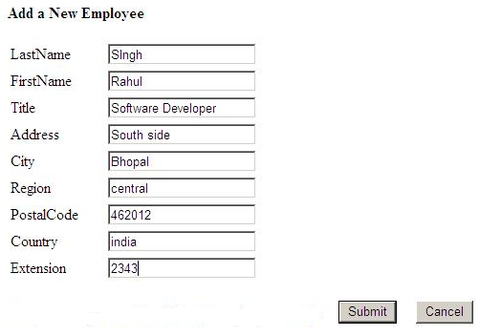
[7+3]

Q.9. a) Explain Session State, Cookies and View State used in.NET Application. [5]

b) Why Field level and Form level ASP.NET validation controls are required in ASP.NET application? Explain different types of validation controls available in ASP.NET. [1+ 4]

Q.10. Write short notes on any FOUR [4×2.5 = 10]
(a) Dynamic Array
(b) IIS
(c) Differentiate between switch case and Nested if else
(d) Events
(e) Web Server

The End

